**Building Chatbot And Integrate To Application**

|  |  |
| --- | --- |
| **Date** | 02 November 2022 |
| **Team ID** | PNT2022TMID17944 |
| **Project Name** | Smart Fashion Recommender Application |

**BUILDING CHATBOT:**

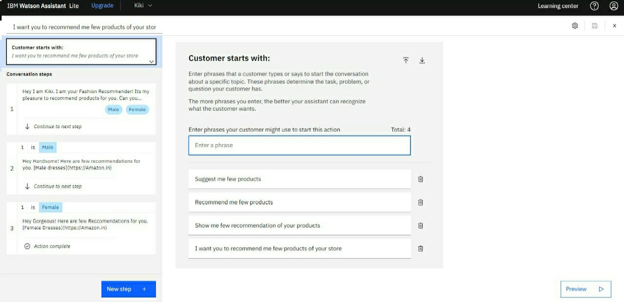

**CHATBOT INTEGRATION:**

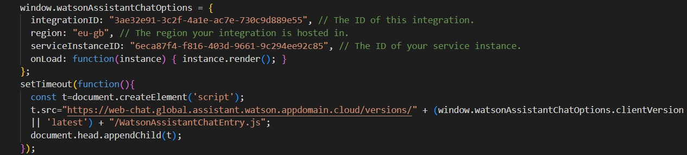

**CHATBOT:**

